Common Approaches to Teaching Maths

PDST Numeracy Recommendations
  - Fractions
  - Percentages
  - Graphs
  - Statistics
  - Decimals
  - Rations

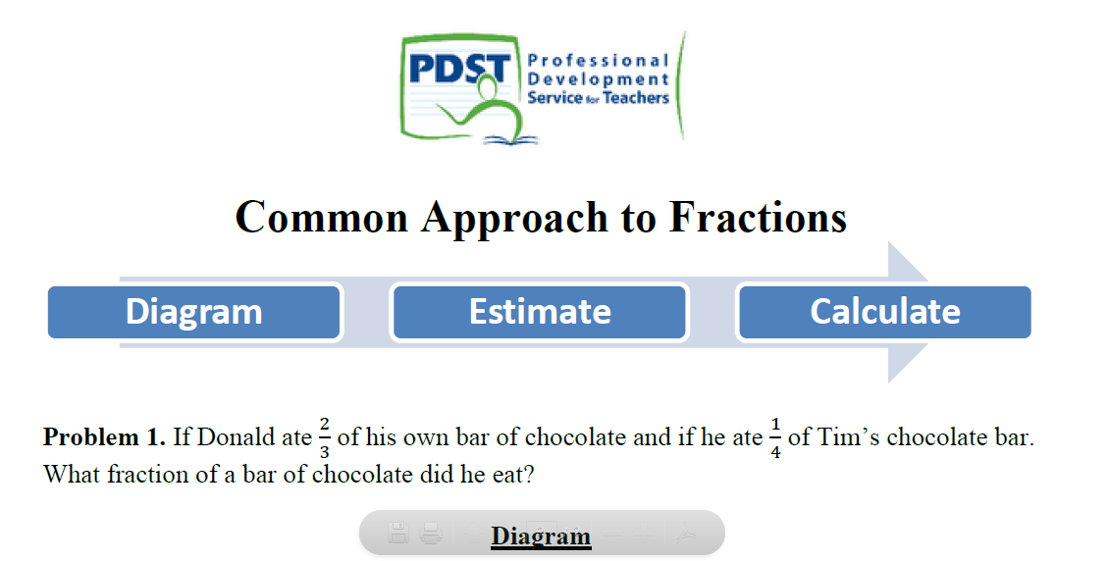
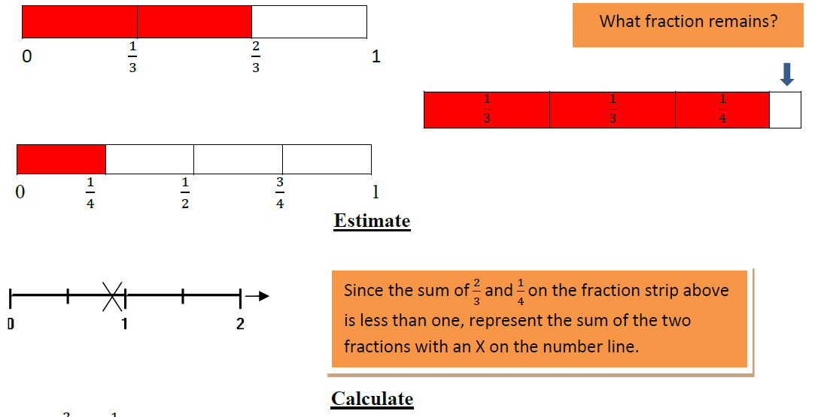
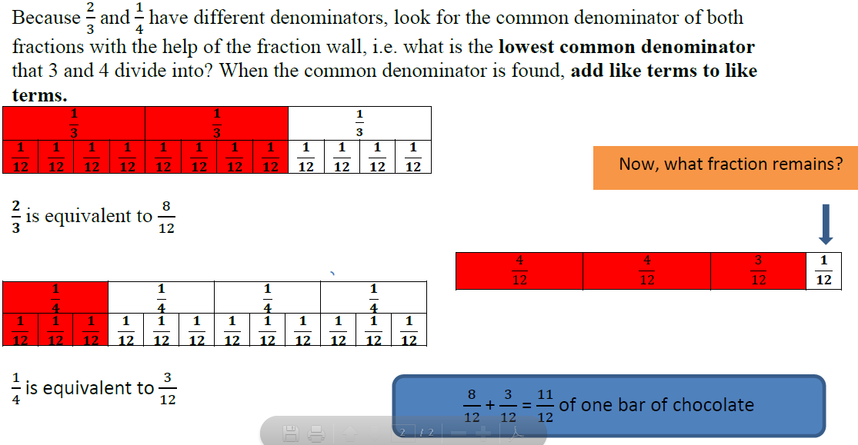
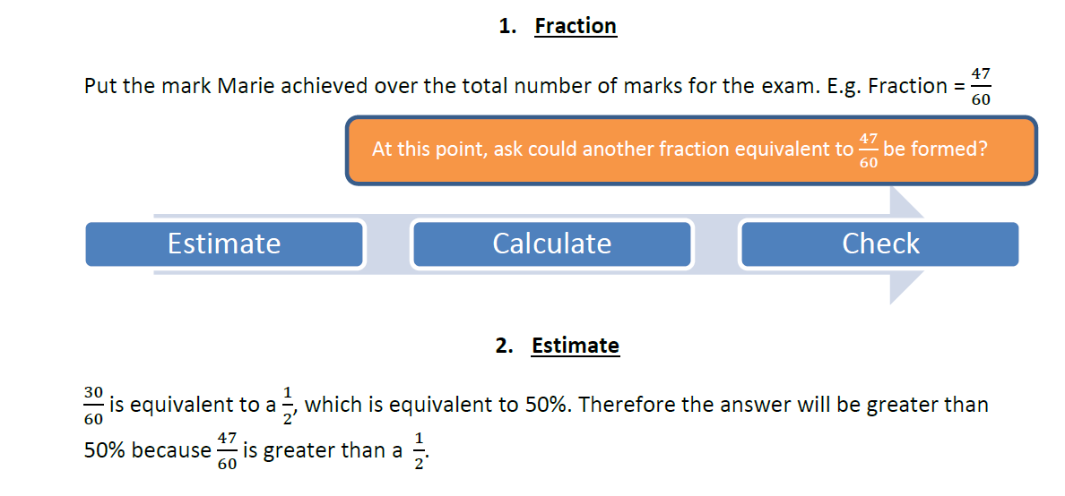
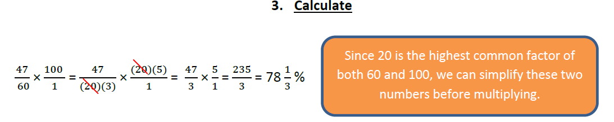
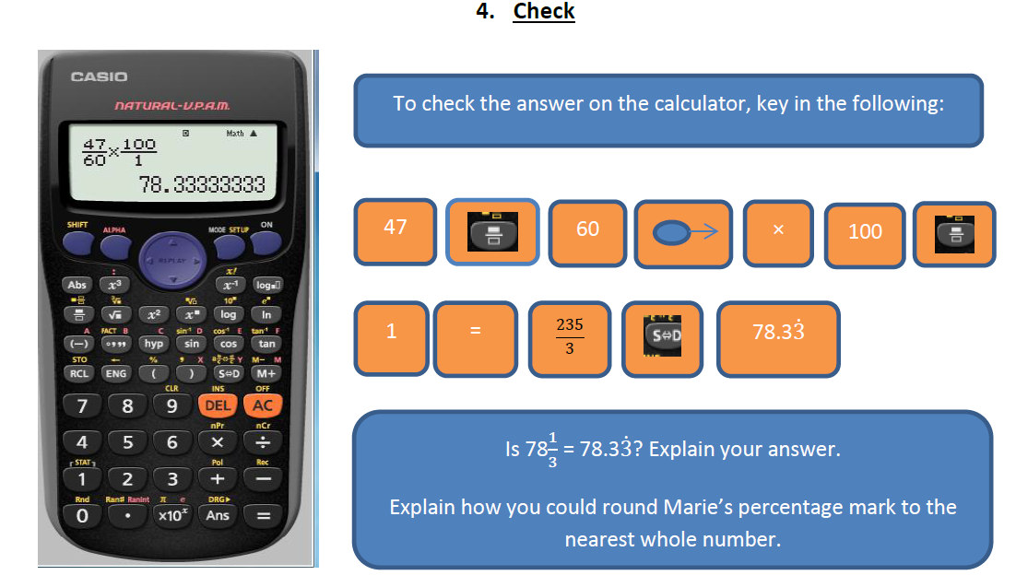

Graphic Analysis-A Common Approach for Bar Charts and Trend Graphs
When analysing bar charts and trend graphs it is good practice to describe what the graph is measuring. If there is no title you should give a description of what the two axes (i.e. the horizontal line and the vertical line) are representing.
• Two aspects of the graph that are important to look are the measures of spread of the data and the central tendency of the data.

Here is a toolkit for analysis:
Measure of Spread
• Range: The difference between the largest value and the smallest value.
• Standard Deviation: The standard deviation measures the dispersion or spread of data from the mean. The smaller the standard deviation, the less widely dispersed (or spread) the data is. This means that more measurements are closer to the mean.

Measure of Central Tendency
• Mean: The average number of the data. The mean is calculated by calculating the sum of all the numbers in the data and then dividing the sum by the number of numbers. In some cases the mean can be a poor measure of central tendency. For instance, if an 80 year old is included in the average age of a first year college class then the mean age will be higher as a result, not reflecting accurately the central tendency of the data.
• Median: The middle number when the data is arranged in order. The median is found by writing the array of numbers out in order of their size and then picking the middle number.
• Mode: The number that occurs most often. For example if there are five candidates in an election and first past the post is deemed elected, then the mode or the modal person is the elected candidate because they receive the most votes.

