Chanel College JCSP Newsletter

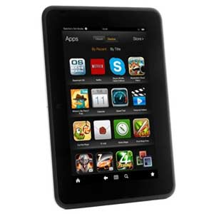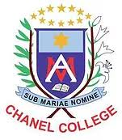

DIGITAL LIBRARY

JCSP Students have been given access to an online digital library through the JCSP. They are using Kindle fires to read books online borrowed from the SORA app. This app can be downloaded on any smart device and used at home by students and parents. For extra information contact Mr Fahy at the school.

Student feedback:

*It was nice reading with my mates*

*I never used a Kindle before*

*I could read any book I wanted, they had loads on every topic*



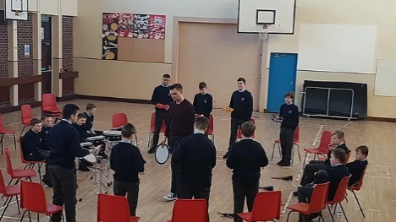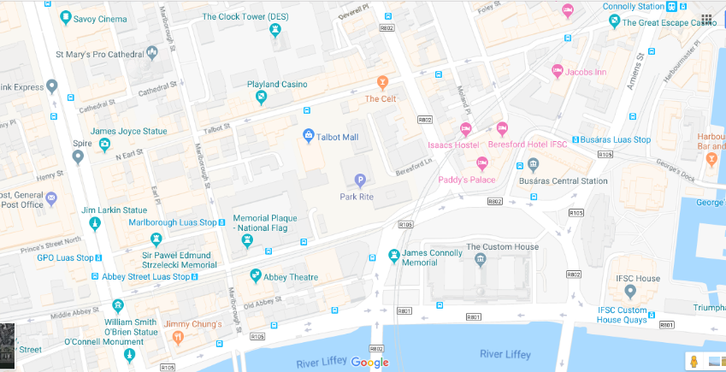

LIFE SKILLS MODULE

Students worked on a household budget using set amounts of money and a LIDL brochure. They were challenged to buy family meals, plan Halloween and Christmas parties and try to manage a budget. They even learned how to time cooking a turkey for their Christmas dinner.

Student feedback:

*I liked trying to keep to a budget*

*I liked adding up the cost of a party, but I didn't like that we didn't get to buy the sweets!!!!*

*It was weird that math's was fun*

DRUMMING WORKSHOP

1st year JCSP students enjoyed a morning's drumming workshop with the Mobile Music School. The great rhythms could be heard along the Chanel corridors as the budding rock stars got to try out different percussion instruments and make lots of noise.

Student feedback:

*I had never played an instrument before so it was good to get to play the drums*

*Learning about different types of drums was good*

*I liked when we all got to play the beats together at once…..we actually sounded good*!!

WALKING TOUR OF DUBLIN

On Thursday 13th December 3rd year JCSP students took part in a walking tour of Dublin as part of their JCSP Christmas celebration. They visited several historical monuments in Dublin’s city centre such as the Talbot St Memorial to the victims of the 1974 bombings and Jim Larkin’s statue on O’Connell Street.

The students found information on the sights themselves and planned the trip too. In Mr Fahy's words "It was all their own work".

It was a very interesting tour and enabled the lads to learn about the history of their city and forefathers in a more active and stimulating way. They had great fun and were challenged to read the map and figure out and find the monuments.

Thanks to Mr McCarthy for his insightful historical commentary.

Student feedback:

*I learned how to use google maps properly and it was good working in groups*

*The tour was great fun*

*Learning about the monuments was great fun*

*Learning the street names on the route was good*

*I enjoyed learning how to write a proper letter*

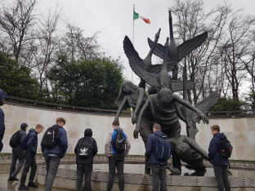

Coming next term;

* Student statements. 2nd Year Art workshop.
* 3rd Year Debating. 1st Year Pi Day