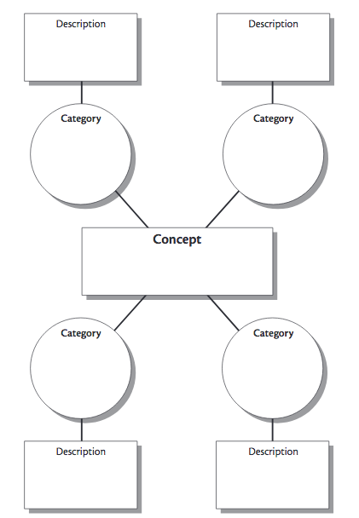

Key Term

Key Term

Key Term

Key Term